**Jenkins Build Pipeline View job Creation**

**Create Simple Build Pipeline View:**

**Build Pipeline View:**

**Step1:** Login into Jenkins ----> Dashboard ----> Manage Jenkins ---> ManagePluggins ----> Available Pluggins ----> search “**Build Pipeline**” and check the check box 🡪click **Download now and install after restart** button.

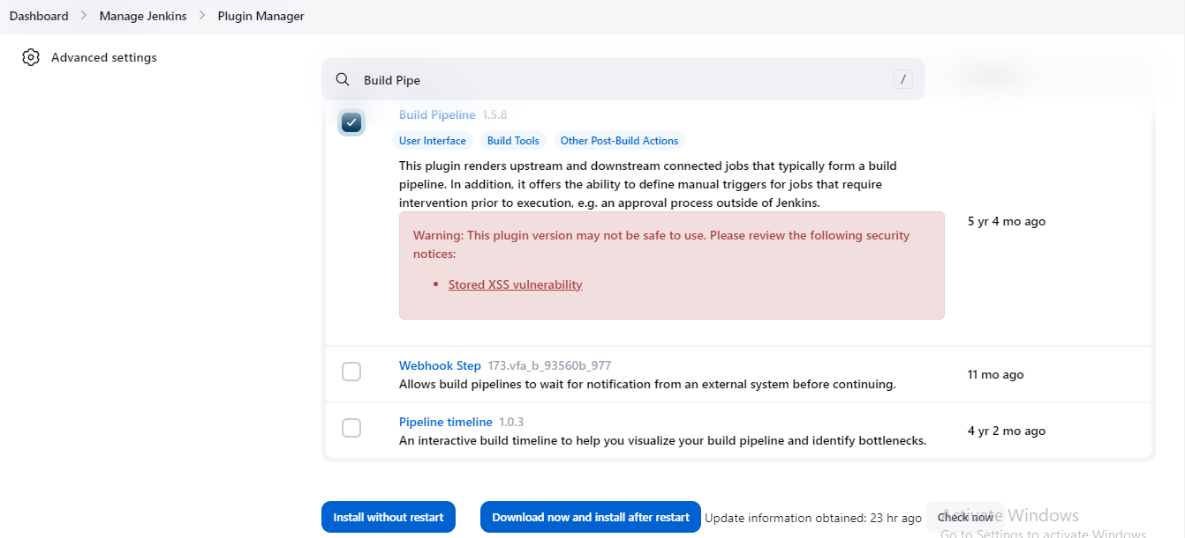

**Step2: Now click on + (New View) Not New Item one:**

You will see the below highlighted one and click Create button.

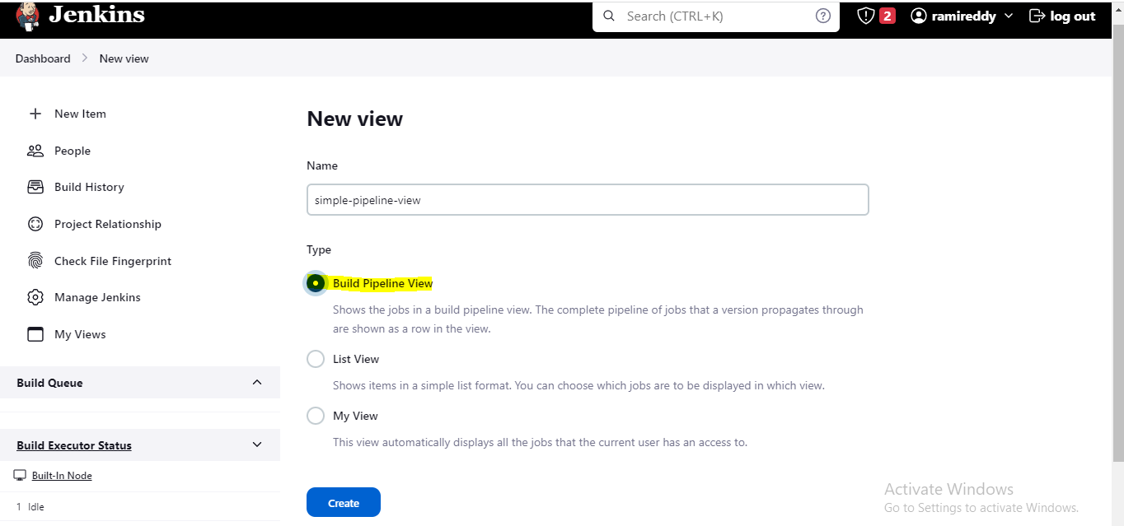

**Step3**: Now in order to create a new pipeline view first I will go and create three simple jobs with freestyle projects this is just for demo only.

Job names are :demo-pipeline1, demo-pipeline2 and demo-pipeline3

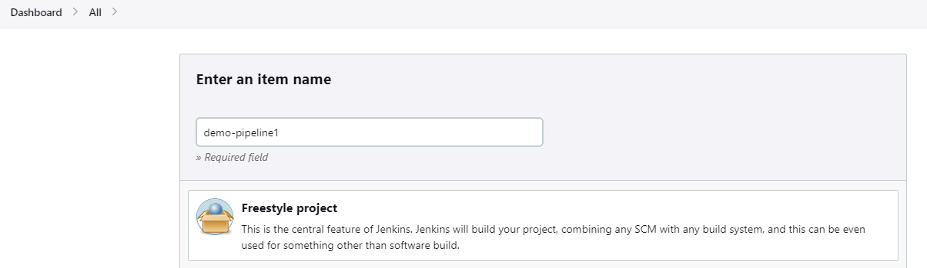

**Step4**: Go to respective jobs and provide the any description and go to build step and select Execute shell and give **echo “First Project”** 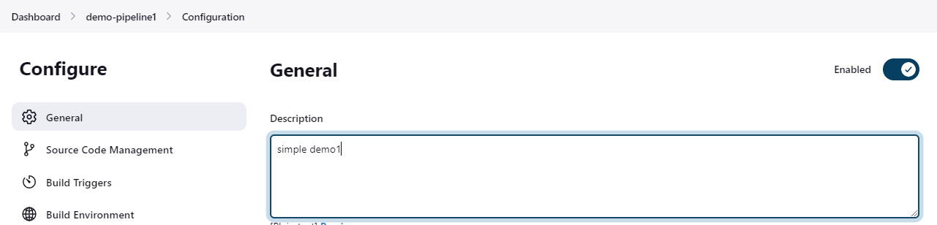

**In Build Step**

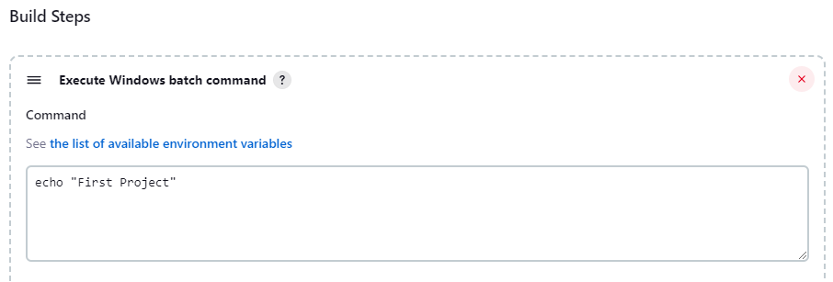

**Note**: Repeat Step3 for second job and third job with different names.

**Step5**: Now we have create three freestyle projects jobs successfully.

Now click on first job (demo-pipeline2) ----> configure --> go to post build actions sections and select “**Build Other Projects”** and select demo-pipeline-2 project**.**

We selected below **Trigger only build is stable** that means if first job is success then only trigger the second build else don’t run.

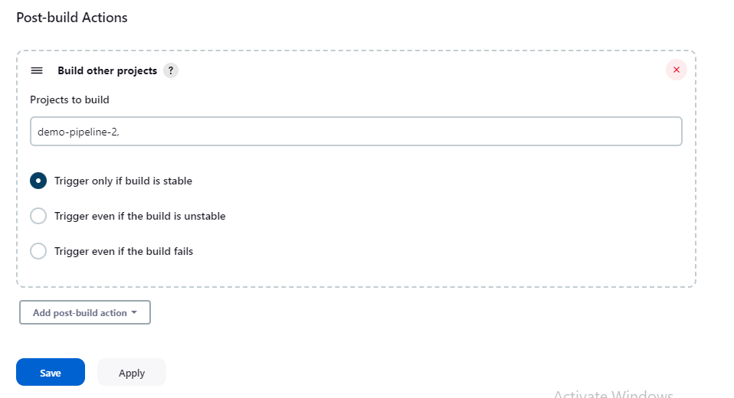

**Note**: Similarly go to second job -> configure-> post build actions -> Build other project and select **“demo-pipeline-3”**

**Step1:** Now go to Dashboard --> click on **+ sign (new view) and** click create button.

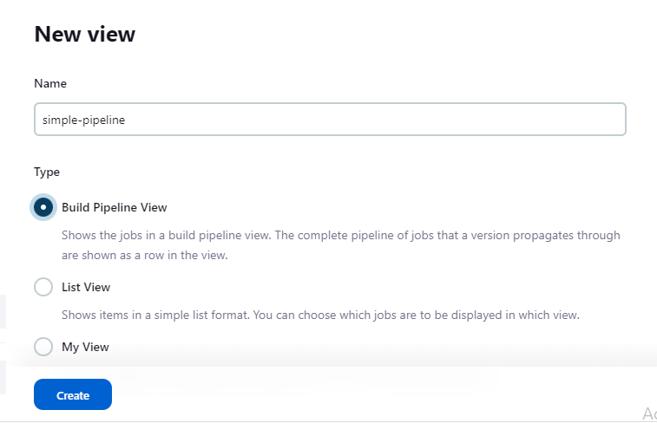

**Step2:** After create pipeline view and scroll down to pipeline flow and select



